Practical

To create a Python Application

Step1: create a folder

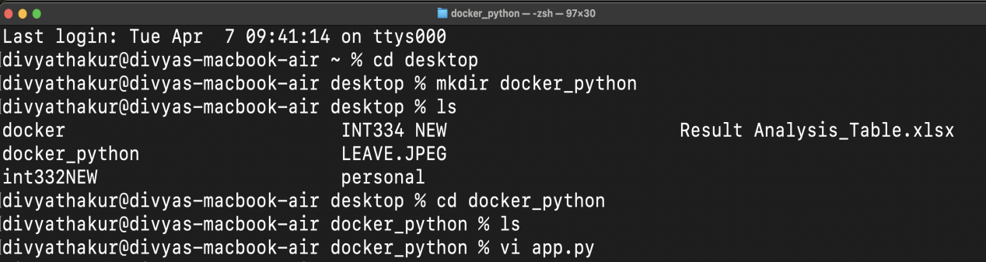

Step1: create a folder
Step2: create a file name app.py
from flask import Flask
app = Flask(_name_)
@app.route("/")
def home():
return "Hello from Docker!”
app.run(host="0.0.0.0", port=5000)

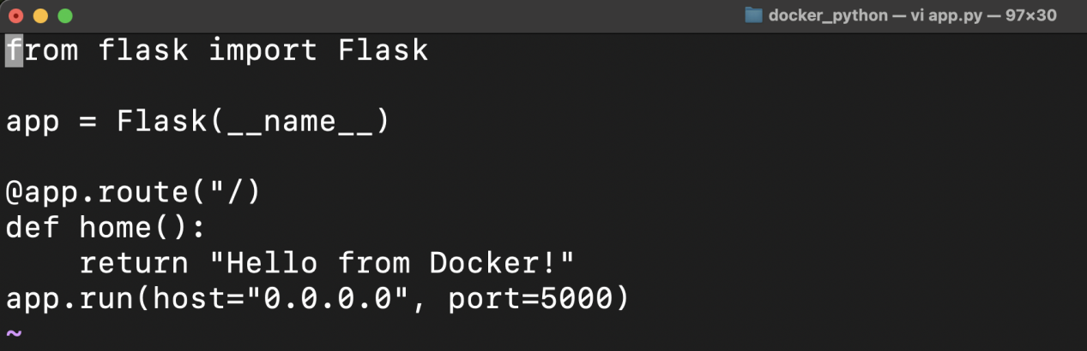

Step3: create another filename requirement.txt (write flask in it)

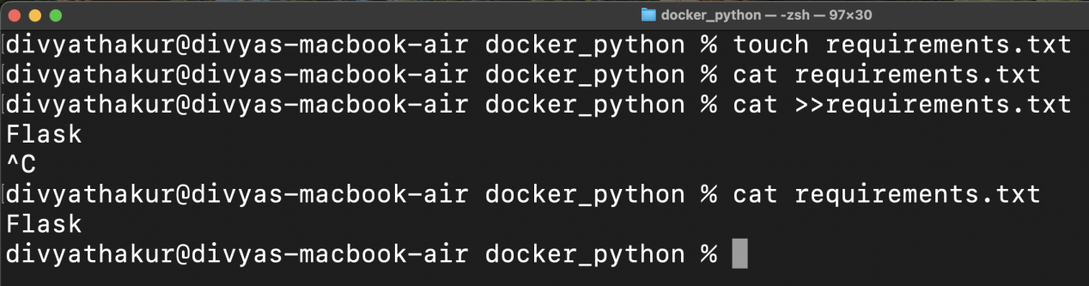

Step4: create the dockerfile
# 1. Base image
FROM python:3.11-slim
# 2. Set working directory
WORKDIR /app
# 3. Copy dependency file
COPY requirements.txt
.# 4. Install dependenciesRUN pip install --no-cache-dir -r requirements.txt
# 5. Copy application code
COPY . .
# 6. Expose port
EXPOSE 5000
# 7. Run the app
CMD ["python", "app.py"]

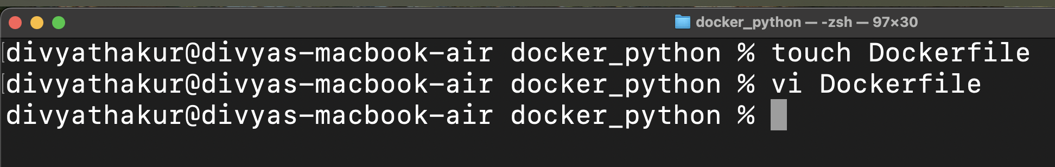
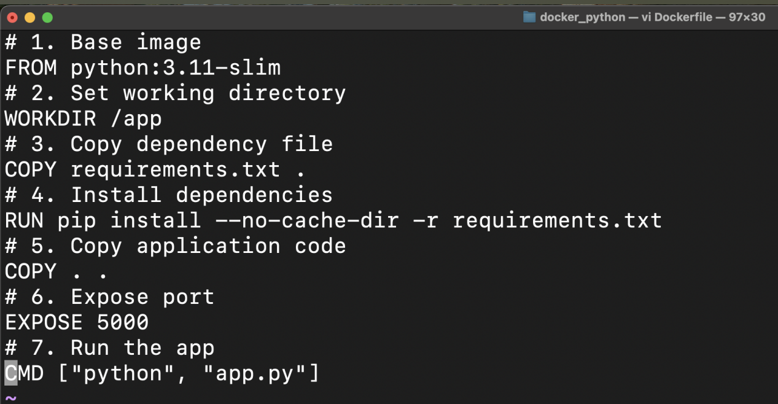
Step5: check the directory
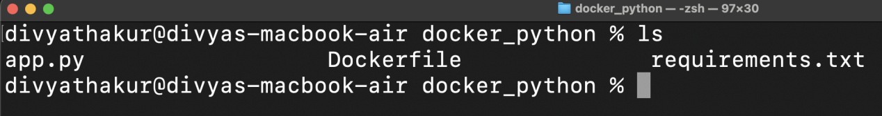

Step6: Build the image

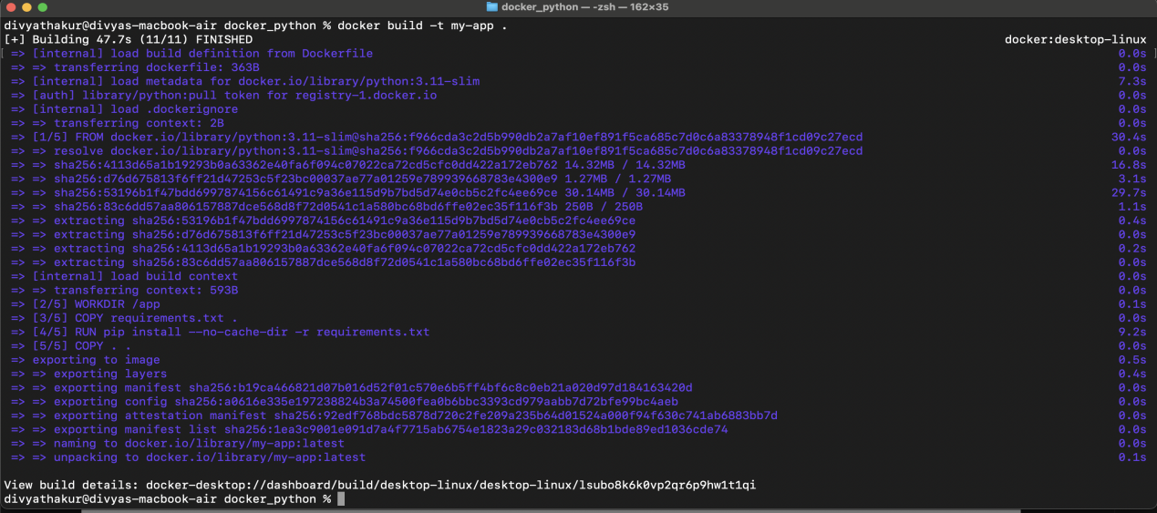

Step7: check the image build
Step8: do the port mapping

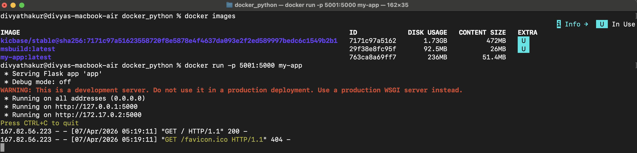

Step9: run the server on the browser
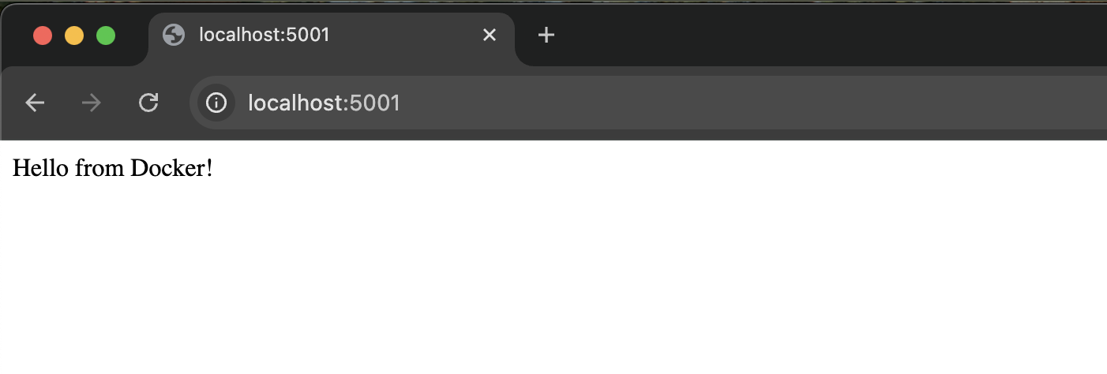

# Create another application from python using flask
Step1: Create the new app2.py file
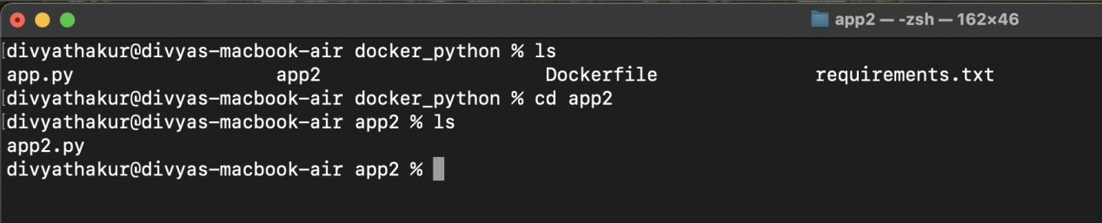
Step2: Write code
from flask import Flask, request
app = Flask(__name__)
@app.route("/", methods=["GET", "POST"])
def home():
if request.method == "POST":
name = request.form.get("name")
return f"Hello {name}! (from Docker)"
return """
<h2>Simple Flask Form</h2>
<form method="post">
<input type="text" name="name" placeholder="Enter name" required>
<button type="submit">Submit</button>
</form>
"""if __name__ == "__main__":
app.run(host="0.0.0.0", port=5000)
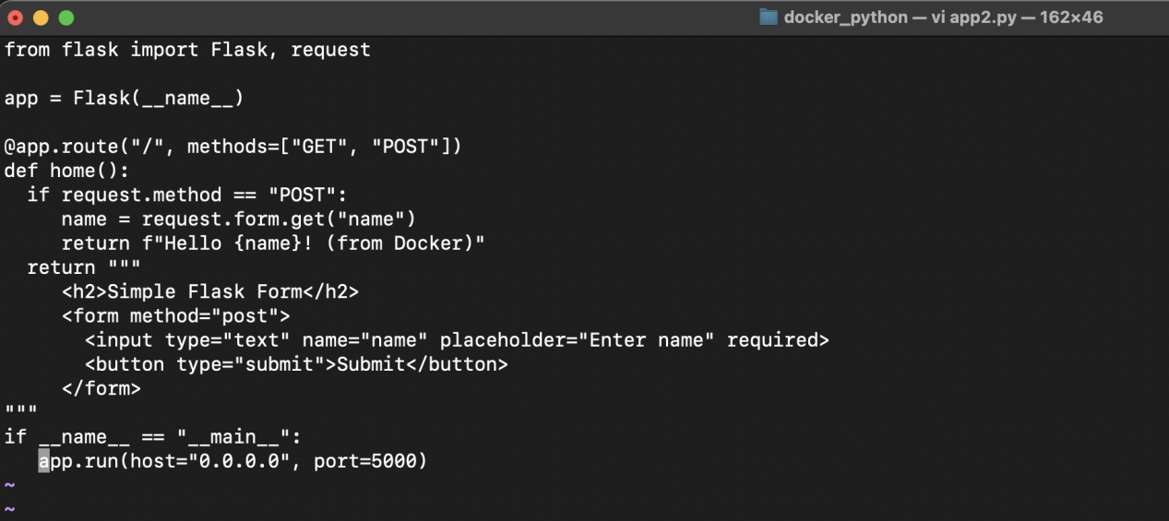
Step3: create Requiremnets.txt and dockerfile

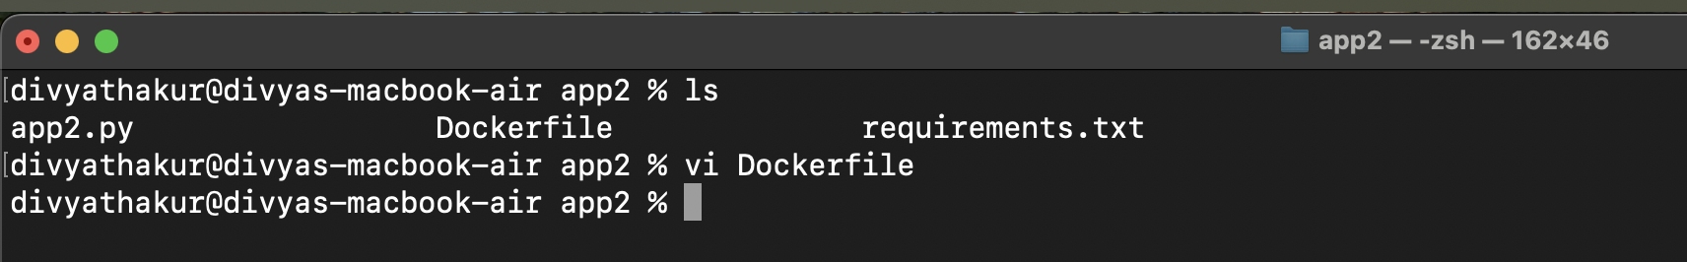

Step4: Add the contents in that dockerfile.txt
# 1. Base image
FROM python:3.11-slim
# 2. Set working directory
WORKDIR /app
# 3. Copy dependency file
COPY requirements.txt
.# 4. Install dependencies
RUN pip install --no-cache-dir -r requirements.txt
# 5. Copy application code
COPY . .
# 6. Expose port
EXPOSE 5000
# 7. Run the app
CMD ["python", "app2.py"]

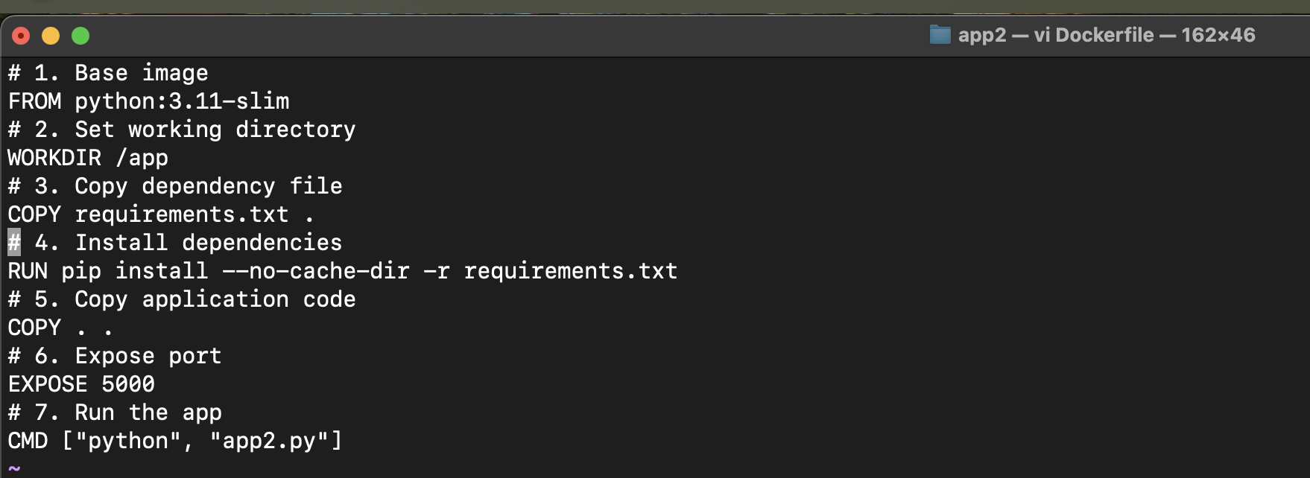

Step5: Save the file and exit , then build
Step6: Do the port mapping

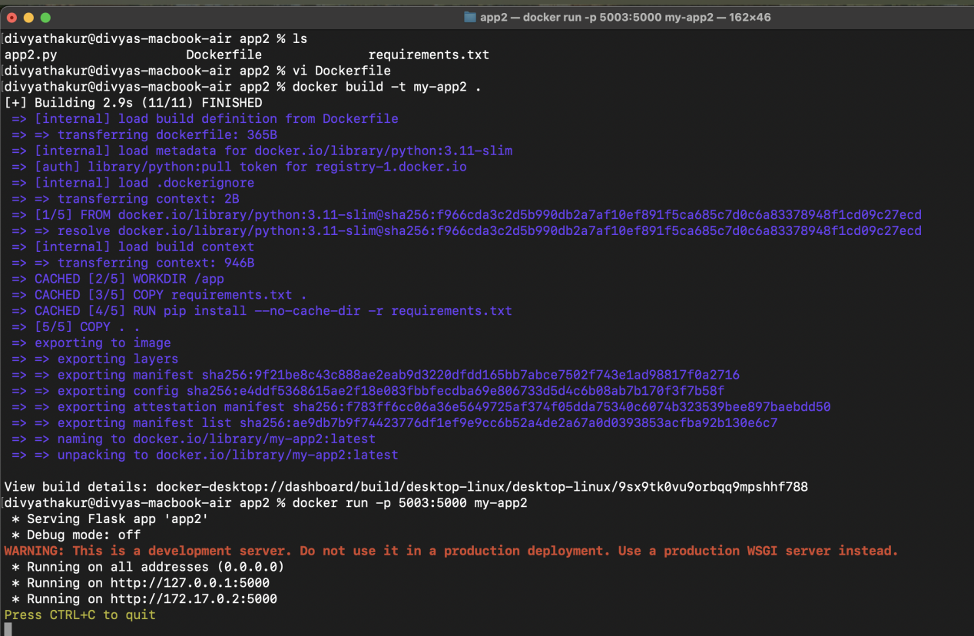

Step7: Run the server on browser

